Software project management

A project is a group of tasks that need to complete to reach a clear result. A project also defines as a set of inputs and outputs which are required to achieve a goal. Projects can vary from simple to difficult and can be operated by one person or a hundred.

Software project management is an art and discipline of planning and supervising software projects. It is a sub-discipline of software project management in which software projects planned, implemented, monitored and controlled.

It is a procedure of managing, allocating and timing resources to develop computer software that fulfills requirements.

In software Project Management, the client and the developers need to know the length, period and cost of the project.

Need of software project management?

There are three needs for software project management. These are:

1. Time
2. Cost
3. Quality

It is an essential part of the software organization to deliver a quality product, keeping the cost within the client?s budget and deliver the project as per schedule. There are various factors, both external and internal, which may impact this triple factor. Any of three-factor can severely affect the other two.

Project Manager

A project manager is a character who has the overall responsibility for the planning, design, execution, monitoring, controlling and closure of a project. A project manager represents an essential role in the achievement of the projects.

A project manager is a character who is responsible for giving decisions, both large and small projects. The project manager is used to manage the risk and minimize uncertainty. Every decision the project manager makes must directly profit their project.

Role of a Project Manager:

**1. Leader**

A project manager must lead his team and should provide them direction to make them understand what is expected from all of them.

**2. Medium:**

The Project manager is a medium between his clients and his team. He must coordinate and transfer all the appropriate information from the clients to his team and report to the senior management.

**3. Mentor:**

He should be there to guide his team at each step and make sure that the team has an attachment. He provides a recommendation to his team and points them in the right direction.

Responsibilities of a Project Manager:

1. Managing risks and issues.
2. Create the project team and assigns tasks to several team members.
3. Activity planning and sequencing.
4. Monitoring and reporting progress.
5. Modifies the project plan to deal with the situation.

Activities of Software Project Management

Software Project Management consists of many activities, that includes planning of the project, deciding the scope of product, estimation of cost in different terms, scheduling of tasks, etc

**The list of activities are as follows:**

1. Project planning and Tracking
2. Project Resource Management
3. Scope Management
4. Estimation Management
5. Project Risk Management
6. Scheduling Management
7. Project Communication Management
8. Configuration Management

Now we will discuss all these activities -

**1. Project Planning:** It is a set of multiple processes, or we can say that it a task that performed before the construction of the product starts.

**2. Scope Management:** It describes the scope of the project. Scope management is important because it clearly defines what would do and what would not. Scope Management create the project to contain restricted and quantitative tasks, which may merely be documented and successively avoids price and time overrun.

**3. Estimation management:** This is not only about cost estimation because whenever we start to develop software, but we also figure out their size(line of code), efforts, time as well as cost.

If we talk about the size, then Line of code depends upon user or software requirement.

If we talk about effort, we should know about the size of the software, because based on the size we can quickly estimate how big team required to produce the software.

If we talk about time, when size and efforts are estimated, the time required to develop the software can easily determine.

And if we talk about cost, it includes all the elements such as:

* Size of software
* Quality
* Hardware
* Communication
* Training
* Additional Software and tools
* Skilled manpower

**4. Scheduling Management:** Scheduling Management in software refers to all the activities to complete in the specified order and within time slotted to each activity. Project managers define multiple tasks and arrange them keeping various factors in mind.

**For scheduling, it is compulsory -**

* Find out multiple tasks and correlate them.
* Divide time into units.
* Assign the respective number of work-units for every job.
* Calculate the total time from start to finish.
* Break down the project into modules.

**5. Project Resource Management:** In software Development, all the elements are referred to as resources for the project. It can be a human resource, productive tools, and libraries.

Resource management includes:

* Create a project team and assign responsibilities to every team member
* Developing a resource plan is derived from the project plan.
* Adjustment of resources.

**6. Project Risk Management:** Risk management consists of all the activities like identification, analyzing and preparing the plan for predictable and unpredictable risk in the project.

Several points show the risks in the project:

* The Experienced team leaves the project, and the new team joins it.
* Changes in requirement.
* Change in technologies and the environment.
* Market competition.

**7. Project Communication Management:** Communication is an essential factor in the success of the project. It is a bridge between client, organization, team members and as well as other stakeholders of the project such as hardware suppliers.

From the planning to closure, communication plays a vital role. In all the phases, communication must be clear and understood. Miscommunication can create a big blunder in the project.

**8. Project Configuration Management:** Configuration management is about to control the changes in software like requirements, design, and development of the product.

The Primary goal is to increase productivity with fewer errors.

**Some reasons show the need for configuration management:**

* Several people work on software that is continually update.
* Help to build coordination among suppliers.
* Changes in requirement, budget, schedule need to accommodate.
* Software should run on multiple systems.

**Tasks perform in Configuration management:**

* Identification
* Baseline
* Change Control
* Configuration Status Accounting
* Configuration Audits and Reviews

**People involved in Configuration Management:**

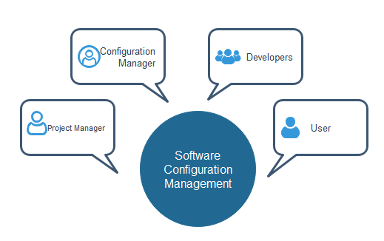

# Lines of Code (LOC) in Software Engineering

A **line of code (LOC)** is any line of text in a code that is not a comment or blank line, and also header lines, in any case of the number of statements or fragments of statements on the line. LOC clearly consists of all lines containing the declaration of any variable, and executable and non-executable statements. As Lines of Code (LOC) only counts the volume of code, you can only use it to compare or estimate projects that use the same language and are coded using the same coding standards.

**Features :**

* Variations such as “source lines of code”, are used to set out a codebase.
* LOC is frequently used in some kinds of arguments.
* They are used in assessing a project’s performance or efficiency.

**Advantages :**

* Most used metric in cost estimation.
* Its alternates have many problems as compared to this metric.
* It is very easy in estimating the efforts.

**Disadvantages :**

* Very difficult to estimate the LOC of the final program from the problem specification.
* It correlates poorly with quality and efficiency of code.
* It doesn’t consider complexity.

void main()

{

int fN, sN, tN;

cout << "Enter the 2 integers: ";

cin >> fN >> sN;

// sum of two numbers in stored in variable sum

sum = fN + sN;

// Prints sum

cout << fN << " + " << sN << " = " << sum;

return 0;

}

Here also, If LOC is simply a count of the numbers of lines then the above function shown contains 11 lines of code (LOC). But when comments and blank lines are ignored, the function shown above contains 9 lines of code (LOC).

# Project Scheduling

**Project schedule** simply means a mechanism that is used to communicate and know about that tasks are needed and has to be done or performed and which organizational resources will be given or allocated to these tasks and in what time duration or time frame work is needed to be performed. Effective project scheduling leads to success of project, reduced cost, and increased customer satisfaction. Scheduling in project management means to list out activities, deliverables, and milestones within a project that are delivered.

To schedule the project plan, a software project manager wants to do the following:

1. Identify all the functions required to complete the project.
2. Break down large functions into small activities.
3. Determine the dependency among various activities.
4. Establish the most likely size for the time duration required to complete the activities.
5. Allocate resources to activities.
6. Plan the beginning and ending dates for different activities.
7. Determine the critical path. A critical way is the group of activities that decide the duration of the project.

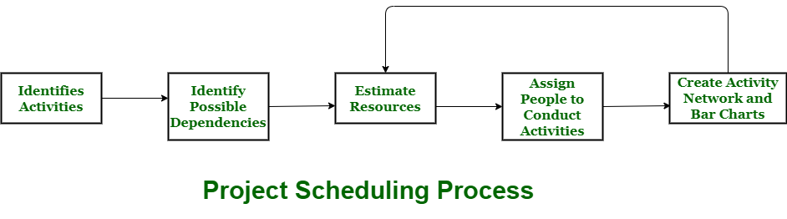

**Process :**  
The manager needs to estimate time and resources of project while scheduling project. All activities in project must be arranged in a coherent sequence that means activities should be arranged in a logical and well-organized manner for easy to understand. Initial estimates of project can be made optimistically which means estimates can be made when all favorable things will happen and no threats or problems take place.

The total work is separated or divided into various small activities or tasks during project schedule. Then, Project manager will decide time required for each activity or task to get completed

**Problems arise during Project Development Stage :**

* People may leave or remain absent during particular stage of development.
* Hardware may get failed while performing.
* Software resource that is required may not be available at present, etc.

**Resources required for Development of Project :**

* Human effort
* Sufficient disk space on server
* Specialized hardware
* Software technology
* Travel allowance required by project staff, etc.

**Advantages of Project Scheduling :**  
There are several advantages provided by project schedule in our project management:

* It simply ensures that everyone remains on same page as far as tasks get completed, dependencies, and deadlines.
* It helps in identifying issues early and concerns such as lack or unavailability of resources.
* It also helps to identify relationships and to monitor process.
* It provides effective budget management and risk mitigation.

**Earned Value Analysis**

EVA is a key tool and technique in Project management. The method helps in understanding the progress of the project based on a quantitative analysis of the Task Budget with the actual value of the task that has been completed.

Earned Value Analysis (EVA) is one of the key tools and techniques used in ***Project Management***, to have an understanding of how the project is progressing

**Features of EVA**

* Earned Value Analysis is an objective method to measure project performance in terms of scope, time and cost.
* EVA metrics are used to measure project health and project performance.
* Earned Value Analysis is a quantitative technique for assessing progress as the software project team moves through the work tasks, allocated to the Project Schedule.
* EVA provides a common value scale for every project task.
* Total hours to complete the project are estimated and every task is given an Earned Value, based on its estimated (%) of the total.
* Earned Value is a measure of ‘Progress’ to assess ‘Percentage of Completeness’

**Need for EVA**

* EVA provides different measures of progress for different types of tasks. It is the single way for measuring everything in a project.
* Provides an ‘Early Warning’ signal for prompt corrective action. The types of signals can be the following:

a)   **Bad news does not age well –** Holding on to the bad news does not help. The project manager needs to take an immediate action.

b)   **Still time to recover –** In case, the project is not going as per schedule and may get delayed, the situation is needed to be taken care of by finding out the reasons that are causing delay and taking the required corrective action.

c)   **Timely request for additional funds –** While there is time to recover, the need for additional resources or funds can be escalated with an early warning.

* It allows ‘rolling up’ the progress of many tasks into an overall project status.
* It provides with a uniform unit of measure (dollars or work-hours) for the progress.

**Key Elements of EVA**

* **Planned Value (PV)**– The approved cost baseline for the work package. It was earlier known as Budgeted Cost of Work Scheduled (BCWS).
* **Earned Value (EV)** – The budgeted value of the completed work packages. It used to be known as Budgeted Cost of Work Performance at a specified point (BCWP).
* **Actual Cost (AC)** – The actual cost incurred during the execution of work packages up to a specified point in time. It was previously called Actual Cost of Work Performed (ACWP).